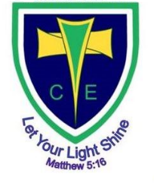
Art
We will start this term by using our drawing skills looking at art from Western Africa and then after half term, move on to painting features of Rococo art

PE
Autumn 1
Monday – Dance – Carnivals.
We will be learning how to dance a Samba.

Thursday – Invasion Games - Football
Please make sure your child reads every night and practices their spelling and multiplication tables on TT Rockstars

Science
Autumn 1 The Circulatory System.
We will discover why the circulatory system is so important, know what blood is made up of and what differing things can affect the system and the blood that flows through it.

Maths
We will start the year by revisiting our previous knowledge, then building on this, learning how to calculate numbers up to 10,000,000
We will then work on the four number operations – addition, subtraction, multiplication and division, ensuring that we can both calculate and problem solving using these skills.

R.E Are science and the Bible account of creation in conflict? What are the different beliefs about it? What do scientists who are Christians believe?

Music: Hey Mr Miller – singing accurately and with expression.
Swing style.
We are reading…
1001 Arabian Nights
PSHE
Autumn 1 – Being me in my world
Our goals for the year, and how our choices affect those around the world as well as ourselves.

Autumn 1 – Geography
North America – Countries, rivers and geographical features. Where are the main population centres, and why?

Autumn 2 – History

WW2 – why did Britain declare war? What was it like for evacuees and on the Home Front? What evidence do we have and how reliable is it?
English 1001 Arabian Nights – learning how to pace stories and move them on, how to use DASH – Description, Action, Speech and How characters think and feel, making up our own story that might fit in.
Recounts and how to make them engaging.

Rowling Class (Year 5/6) are learning… Autumn Term 2024Spring 1

